**ADDING VIDEO BEHIND YOUR SLIDE TEXT**

1. Open a new PowerPoint presentation.
2. Remove the default boxes so that the slide is blank.
3. Go to Insert>Video, then select “This Device” or “Stock Videos.” “Online Videos” will not play in the background, only as a front object, so they do not work for this visualization. The appropriate screen will pop-up.

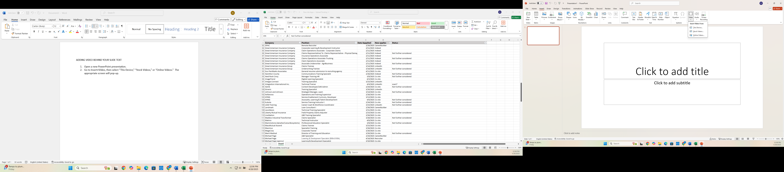

1. This Device: Choose the folder that contains your video or GIF. Be sure to choose “All Files” to enable the GIFs to show up. Either double-click on the file or single-click and hit “Insert.”

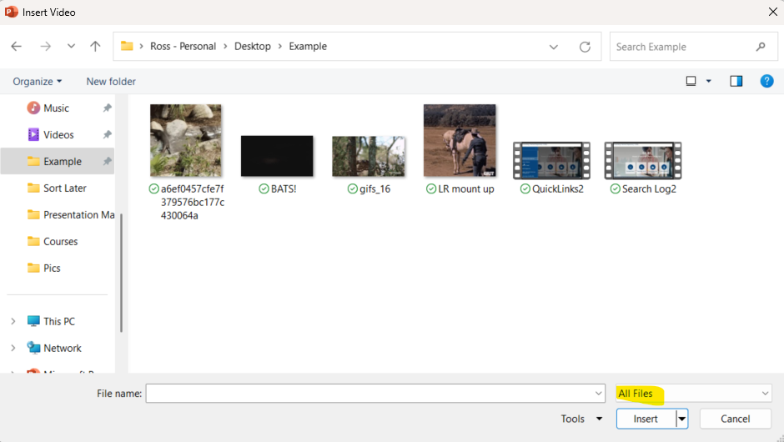

1. Stock Videos: There are many options, organized by theme. Make your choice, then either double-click on the file or single-click and hit “Insert.”

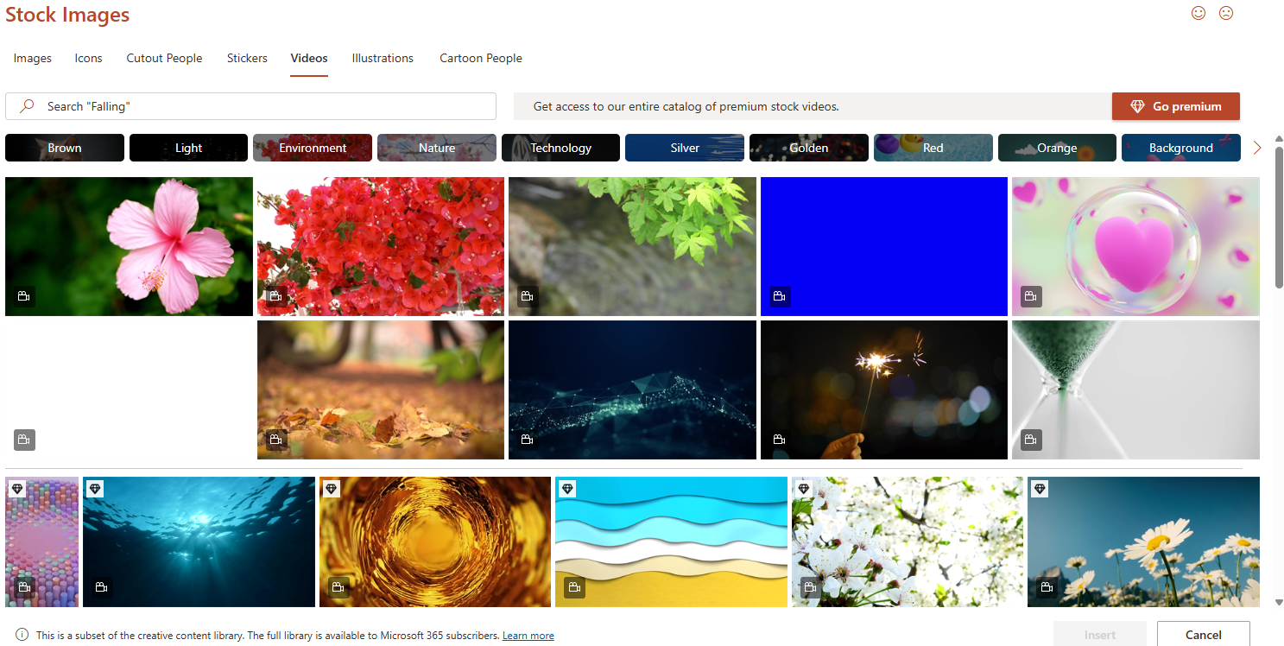

1. Click on the video to ensure that “Video Format” and “Playback” appear at the top of the toolbar. Set the start to “Automatically” and click the box beside “Loop until Stopped.”

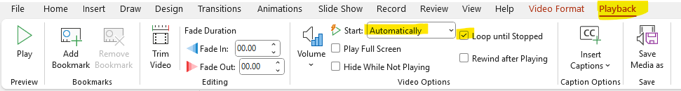

1. Go to Insert>Shapes and choose a rectangle. Draw a rectangle that completely covers the video image. Your image will disappear from view.

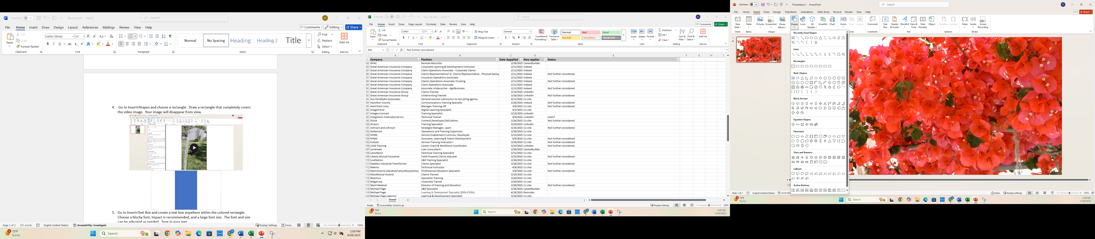



1. Go to Insert>Text Box and create a text box anywhere within the colored rectangle. Choose a blocky font, Impact is recommended, and a large font size. The font and size can be adjusted as needed. Type in your text.

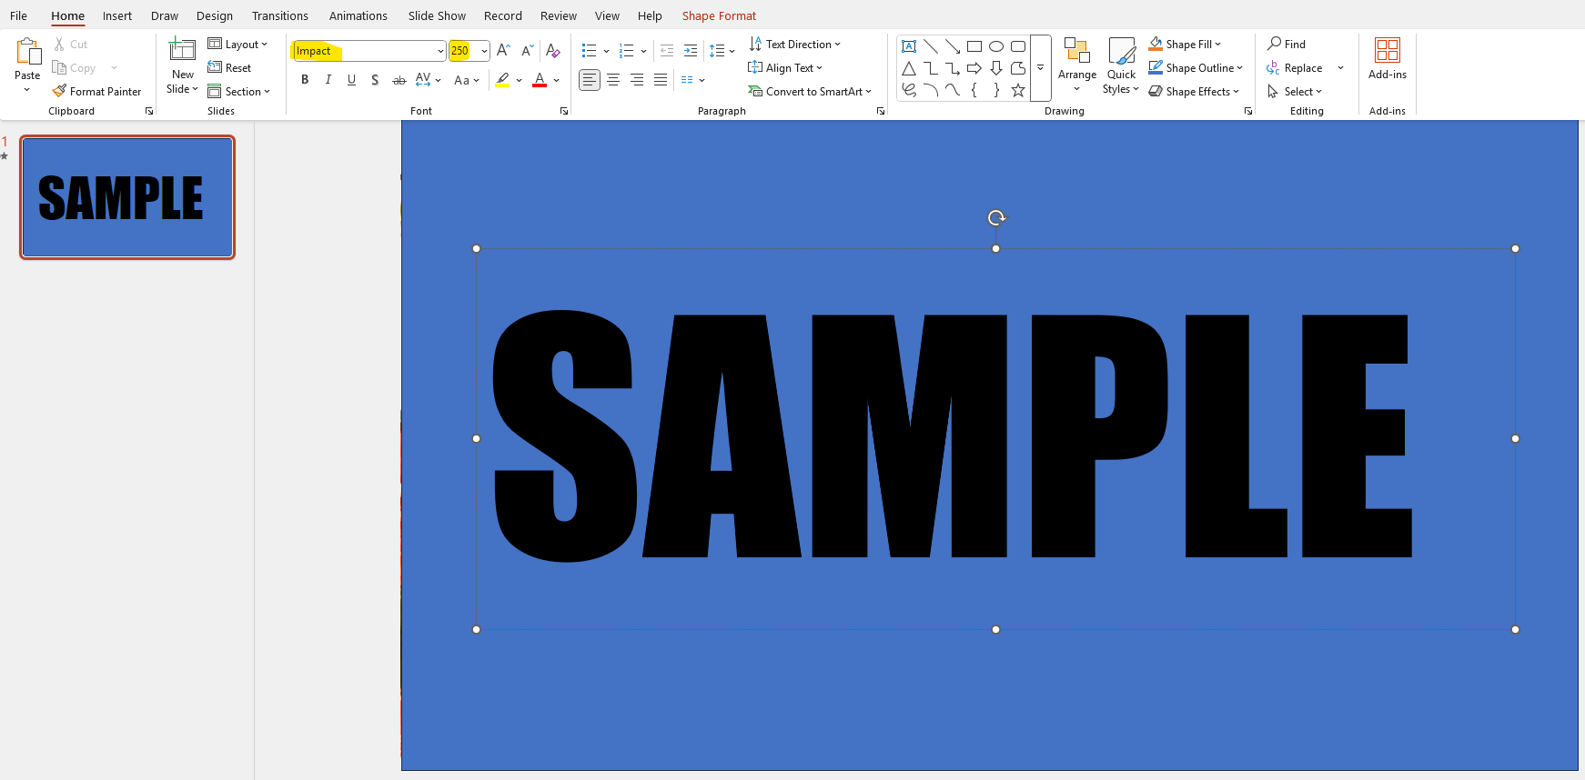

1. With the text box selected, go to Home>Arrange, the hover over Align. You can have the program automatically align the text box anywhere in the slide. For this example, “Align Middle” is chosen.

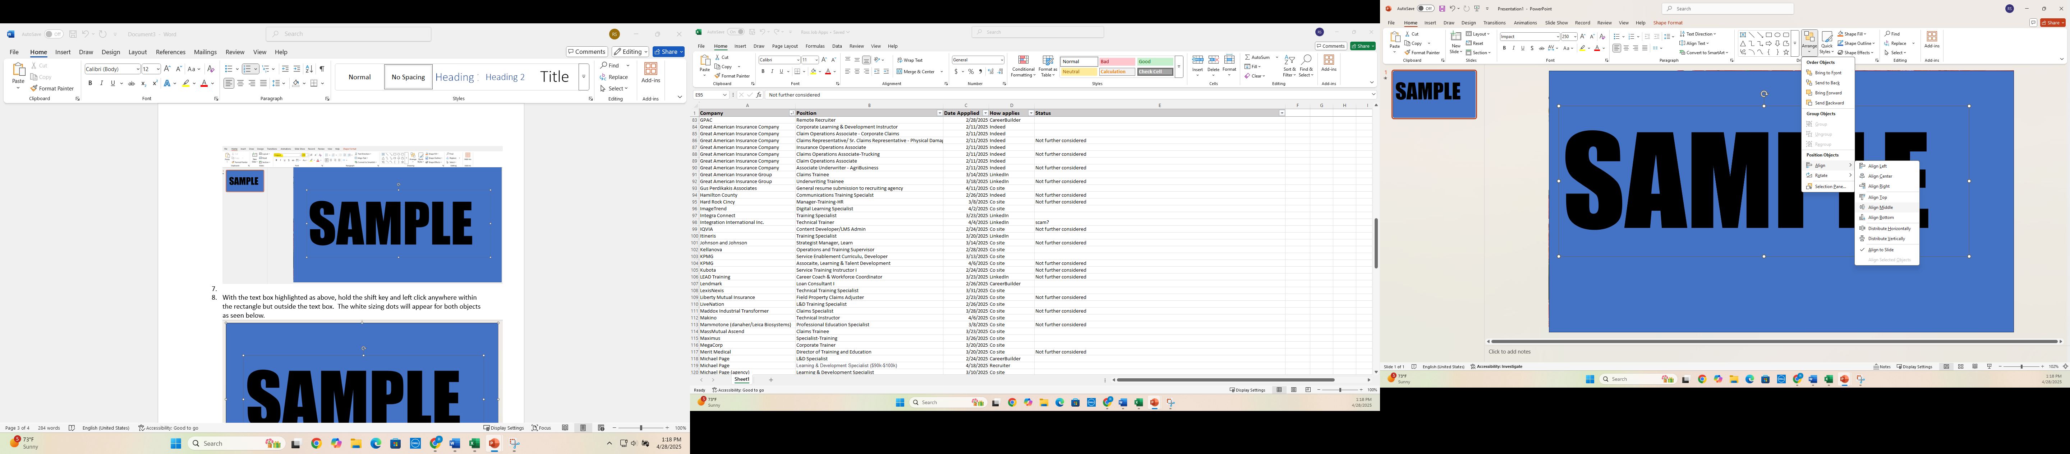

1. With the text box highlighted as above, hold the shift key and left click anywhere within the rectangle but outside the text box. The white sizing dots will appear for both objects as seen below.



1. Go to Shape Format>Merge Shapes and click “Combine.” Hovering over “Combine” will give a preview, with the text transparent so that the video can show through and the rectangle now black in color.

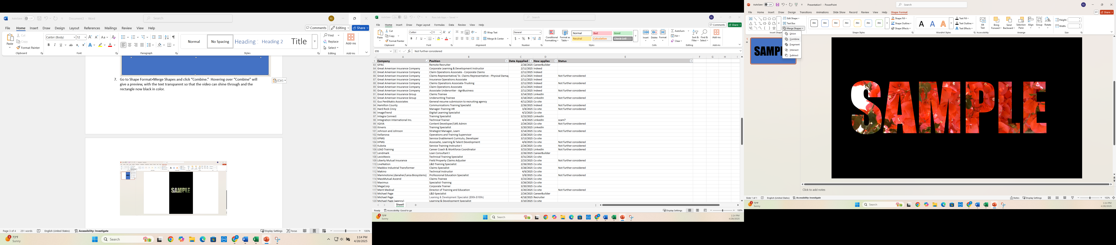

1. Check that the video works by hitting F5, clicking the “Start From Beginning” icon at the very top of the screen, or going to Slide Show>From Beginning or Slide Show>From Current Slide.

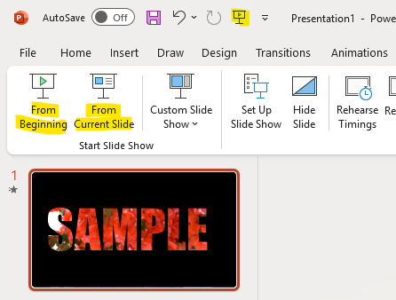

1. If you wish to make any changes in the color of the video overlay, you can click anywhere in the fill color, click “Shape Fill” and preview then choose another color.

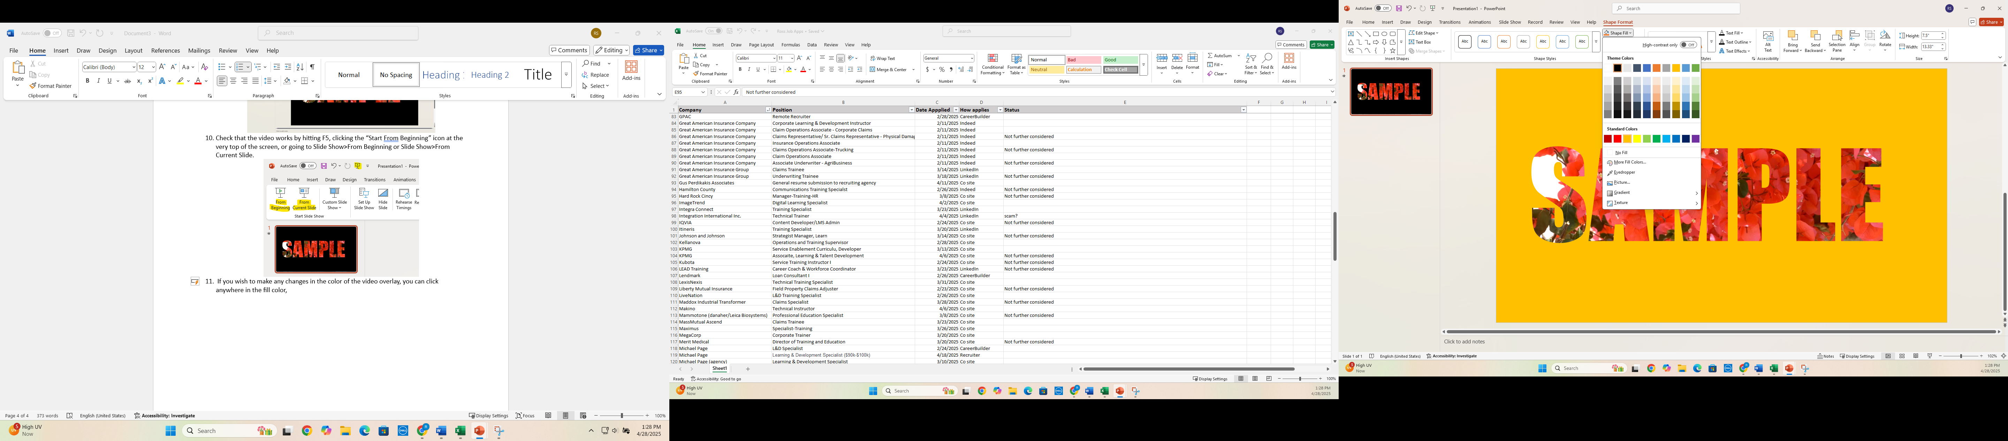

**PLEASE CONSIDER:**

-Keep copyrights and Fair Use principles in mind when choosing videos or animations. Those provided through the PowerPoint program itself are the best to use.

-Also keep company design principles in mind when creating your slide: creating an opening slide for a small team meeting for which your manager has told you to have fun is different than for a presentation that will go before multiple teams or even outside partners.

-Finally, and most importantly, do not use up all of your time and energy making the presentation “dazzle” and neglect the actual information the presentation is meant to share. Work with your manager, mentor or look for other PowerPoint trainings in the company LMS for tips and tricks for creating and presenting informational PowerPoints.